Conservation Area submission [Final Draft]

South Leigh and High Cogges, West Oxfordshire

Updated 30th August 2022

South Leigh & High Cogges Parish Council

Conservation Area submission

South Leigh and High Cogges, West Oxfordshire

1. Introduction and Summary
This application is respectfully submitted following exhaustive preparation comprising:
- A 64 percent support for Conservation Area status in a poll of residents (November 2020).
- A comprehensive draft submission from independent Heritage Consultant, Mr. Graham Keevill, (June 2021).
- A pre-application submitted to the Council’s adviser, Mr. Phil Shaw at Publica Group.
- A revised, final application (this one) supported by (??) percent of voting residents in a further poll in (date ??).
- [??] support from the Parish Council following the second poll.

The Parish of South Leigh and High Cogges lies 2 1/2 miles East of Witney on the Limb Brook, a small tributary of the Thames, and comprises some 130 dwellings of which 16 are listed. It is home to just 336 residents at the last census in 2011 and is, thus, one of the smallest parishes by population yet it covers some seven square miles (some 18 sq. kms).

The settlement is threatened on all sides by the A40 expansion, an anaerobic digester site, and by potential extensive housing developments and solar farms, one that is already in place. In 2018 the Parish successfully completed a Neighbourhood Plan with an overwhelming 92 percent support of the 71 percent of the electorate that turned out in the rain. However, residents are concerned that Neighbourhood Plans are not permanent, nor are they enshrined in law and that they are at the mercy of changes in government policy whereas Conservation Areas provide a significantly more robust level of protection that is enshrined in law. Thus, we submit this application at the wish of residents.

1.1. The South Leigh and High Cogges Dilemma
The Parish’s dilemma with regard to Conservation Area status application is that the majority of the dwellings in the close-knit community are located in five disparate clusters that are spread over two and a half miles from North West to South East (as are its listed properties), and a further third of a mile, Northwards, with spurs of farm land in between that we believe are key to the ‘character and setting’ of the area. We, thus, aspired to having a much wider area that would embrace the interconnecting farm land that acts as the ‘setting’ for and ‘buffer’ between the specific areas of dwellings included in a Conservation Area.

The Parish Council is always at lengths to engage and embrace the dispersed areas of population in all of its actions as well as is within its potential Conservation Area and hoped that this might be achievable with our Conservation Area application. However, both advisers came to a similar conclusion in their advice that the areas of farm land separating the residential clusters within the linear layout of the dwellings, while important, would most likely be cause for our application to fail. Thus, this submission is much revised and is largely based on their advice:

1.2. Our submission
As noted, Mr. Shaw concluded that we should decide on a ‘much more tightly focussed area centred on the village hall, church, pub and estate cottages could (possibly with a limb up Chapel Road to encompass Kimber’s Break)’. We have done this and present this as area ‘Core Area A’, below, extended a little further North West to include the Wayside Cottages, which are National Trust properties.

With regard to High Cogges, our consultant advised that, while being a mile or so to the North West of Core Area A, the High Cogges hamlet is a legitimate ‘self-defining Core Area’ and ‘deserves CA status’.
We, thus, present High Cogges as ‘Core Area B’. We call these combined areas ‘the two villages’ and respectfully request that they be considered for Conservation Area status. Supporting detail follows.

2. The supporting case in detail - Overall plan of the area with key references

The dark outline hatched area is the Parish Council’s aspirational boundary for the Conservation Area. The Orange area is the much-reduced ‘Core Area A’ and ‘Core Area B’ applied for in this submission
Core Area A
Core Area B

High Cogges. Wayside Cottages. Limb up Chapel Road. Pub. Village Hall. Church. Estate Cottages.

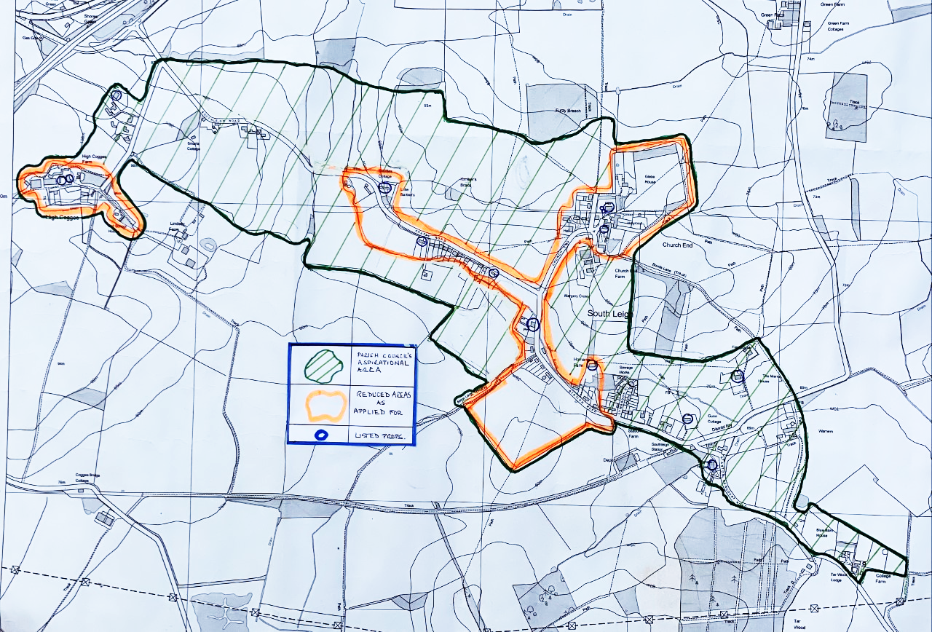
Chapel Road
Station Road
Margery Cross
Core Area B
Core Area A
Football Field

2.1 Application history
The possibility that South Leigh and High Cogges might be designated as a Conservation Area is not new. Important studies were carried out in 2016, and have proved useful in our consideration of what might form a reasonable application. Our Heritage Consultant is in no doubt that the two settlements merit designation.

We understand that modern buildings are not necessarily problematic or need to be excluded. At South Leigh and High Cogges, most of the older buildings have been listed, or are so by virtue of curtilage listing. There is no doubt that these buildings are all of high historic, architectural and aesthetic value both individually, in their settings (there are strong visual links between many of them), and for their group value. Nine of these are located in the two Core Areas of the proposed Conservation Area, excluding the church and graves.

The later 19th-century buildings in the two villages are mostly the result of enlightened development by the Eynsham Park Estate. They are of good architectural quality and design, making an important contribution to the historical and architectural character of the area. The more modern buildings are
well integrated into the historic settlement pattern in scale with these historic houses/cottages and help to link what would otherwise have been very dispersed settlement areas. They, therefore, make a positive contribution as a group (even if few of them contribute individually) to the overall layout and character of South Leigh and High Cogges and are, thus, included.

2.2 Heritage considerations
We understand that the significance of a place’s heritage assets is a major factor in the CA decision. However, the National Planning Policy Framework (2019) makes it clear that locally important (non-designated) heritage assets will also be a factor in local decision making – including on whether a place merits Conservation Area status. The following paragraphs briefly describe/note the heritage assets in South Leigh and High Cogges and we address non-designated assets later.

2.3. Designated heritage assets in the two settlements
The medieval manorial and priory remains at Cogges are the nearest Scheduled Monument (National Heritage List number 1016269), on the other (North) side of the A40 from High Cogges. Eynsham Hall is the nearest registered parkland, at Grade II (NHL 1001288). There are 16 listed structures in South Leigh and High Cogges, all Grade II except for the Grade I Church of St. James the Great. These are summarised below with those in Core Areas A and B printed in green. The others are outside the application areas.

Designated heritage assets
Name |  | Grade | Date/comments
South Leigh
Church of St James |  | I | Late 12th-century and later. Exceptional survival of wall paintings internally.
Grave slab nr church |  | II | Medieval
Grave slab nr church |  | II | Medieval
Church Farmhouse |  | II | Farm/manor house, early 16th century origin with 17th/18th-century and later work
The Cottage |  | II | Late 17th/early 18th-century house (now known as Acre Cot.).
62 Witney Road / Kimble’s Brake |  | II | 17th-century house, now two properties
Wayside Cottage / Upper Wayside C’ge |  | II | 17^{th-} and late 18th-century attached properties
The Mason Arms |  | II | Public house, early 17th-century origin, 18th and 20th-century additions/alterations
Homan’s Farmhouse |  | II | Late 17th century house
Gunn Cottage |  | II | 17th-century house
The Manor House |  | II | Mid-late 17th-century manorial residence, c 1820 alterations
Tar Wood House |  | II | Late 18th/early 19th-century house
High Cogges
High Cogges Farmh’se |  | II | 17th-century house
Granary nr HC Farmh’se |  | II | 17th-century granary adjacent to the farmhouse
9-10 High Cogges |  | II | Late 17th-century house
Ladymead Cottage |  | II | Early 18th-century house

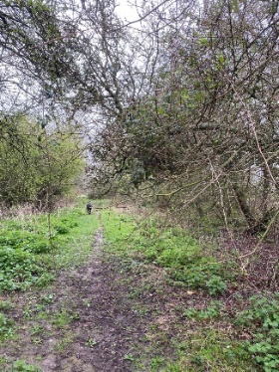
2.4. Non-designated heritage assets
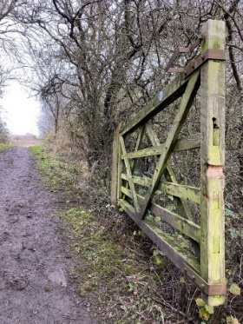
South Leigh contains numerous later 19th-century houses and other buildings (notably the old school - now the Village Hall (see later) - as well as the old Vicarage and sanatorium, (now Holyrood). They are of good design, of high build quality, and are consistent in appearance, detailing and materials. They contribute strongly to the stock of historic buildings and the general character of the place. Though not listed, these are important elements of the settlement pattern and also provide regular historical reference points on a journey through the area. The later 19th-century building stock is largely a legacy from the Eynsham Park Estate, and therefore has strong local historical resonance.

2.5. Other character features
A number of natural and created/historic features make an important contribution to the two villages and their setting:
- The Limb Brook and other water courses are important physical and conceptual threads running through the village weaving one way or the other under five different bridges.
- Old drove ways and paths (above right), especially Moor Lane and Bond’s Lane, that are partially in Core Area A, are extremely important features.
- The disused railway line that runs mostly to the South of the village (Right).
- Remnants of medieval and later ridge and furrow fields survive around and adjacent to the village in Core Area A (Below). Much has been lost to mechanical/deep ploughing in the modern era, but there is still some good survival – and in at least one case near the church, what appears to be earlier archaeological earthworks are also preserved within/by the ridge and furrow.

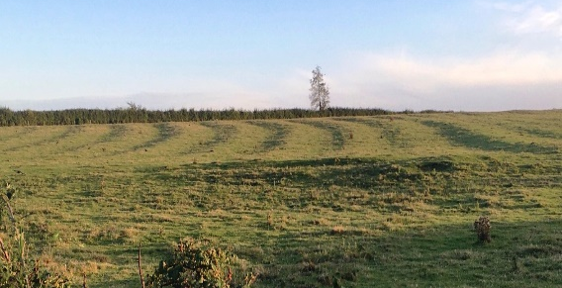
Abutting Station Road: Evidence of ridge-and-furrow farming divided by a hedgerow bank from one of South Leigh’s ancient closes (foreground).

(Below right): Lidar image for the area around the Church of St. James the Great and Bond’s Lane. Note the medieval ridge and furrow to the North-east of the church, apparently with an archaeological earthwork under it.

The two villages also feature on a series of high-quality, detailed surveys and maps from the middle decades of the 19th century onwards. An estate map of 1793, the Tithe Map of 1849, and Ordnance Survey 25-inch (1:2500) maps of 1877 (surveyed 1872-5), 1899 (revised 1898) and 1921 (revised 1919) are the most important, but later editions are useful as well. These maps make it relatively easy to follow the historical development of the village and its buildings in considerable detail.

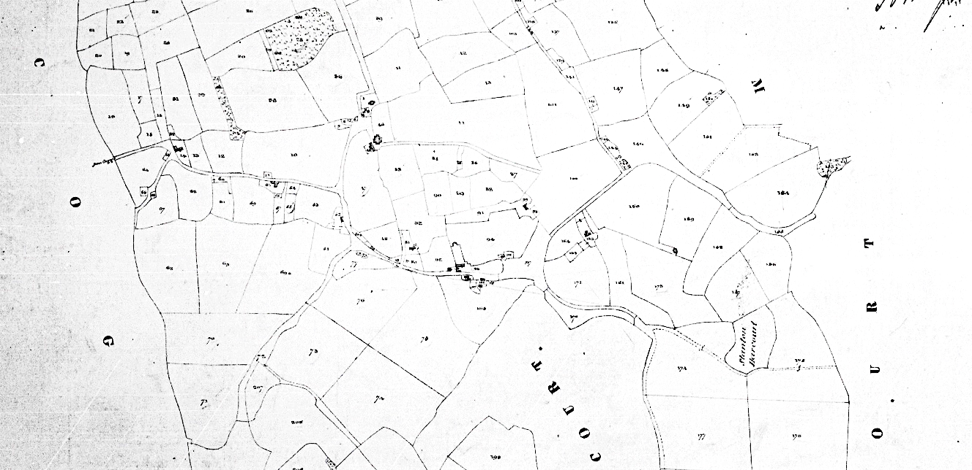

(Above): Extract from the Tithe Map of South Leigh (High Cogges was then in a different Parish), with a relatively sparse distribution of buildings. Church End is circled above and below.

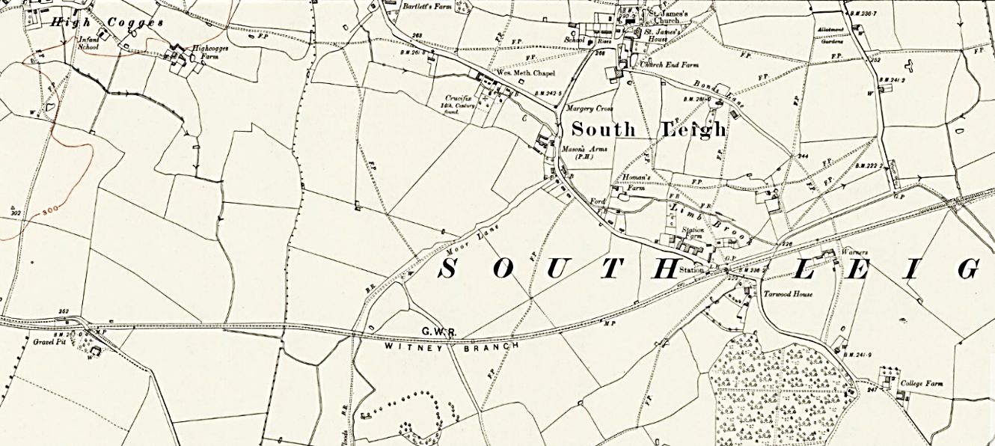

(Above): Extract from the 1921 1:2500 OS map, with Eynsham Estate houses, public and other buildings having been added.

2.6. Modern development
The two villages remained very largely as they were in the late 19th-century until well after World War II. New houses were built in both settlements thereafter, especially during the 1960s. The main concentrations in the submission are West of Margery Cross on Chapel Road (between Acre Cottage and Wayside Cottages) in South Leigh, at Lymbrook Close off Station Road, with a smaller but still important development in High Cogges. There have been relatively few new builds since then.

2.7. Landscape character
The two villages nestle into very attractive open countryside, with the Core Area A of South Leigh around the 14th-Century Church of St. James the Great, and Core Area B, High Cogges, being on the highest ground to the West. There are excellent views from the church area to the South and to the North, while High Cogges also has good views in a number of directions. Views within the villages appear between the gaps in high hedgerows along the slightly sunken lanes, and excellent vistas open up to the rolling farmland on either side at most field entrances. The old paths and railway provide some excellent panoramas, and there are numerous public footpaths that cross-cross the farmland, although in recent months, the 200-acre Tar Farm solar farm is seeking consent to build just 50 metres South of the disused railway (in addition to the existing 140-acre 12-Acre Farm installation that abuts our Parish in the West).

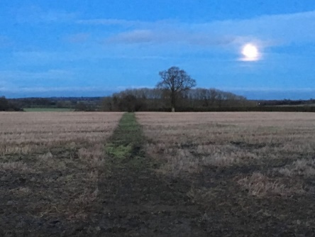
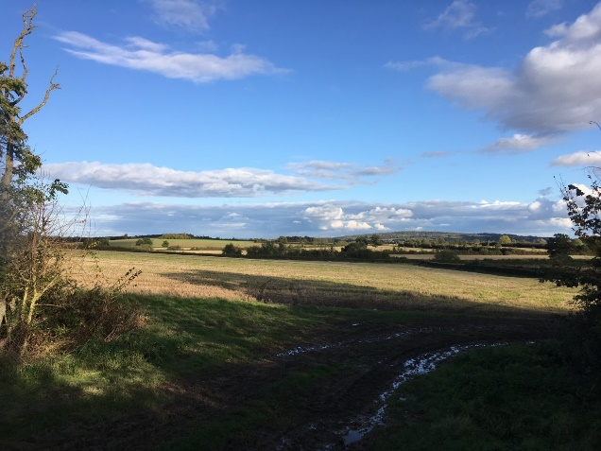
The landscape, therefore, provides a fine frame for South Leigh and High Cogges but their ‘settings’ need to be protected.
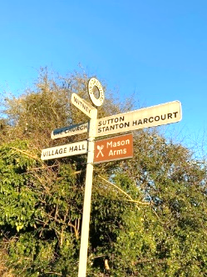
3. The two application areas in detail
3.1. Core Area A:
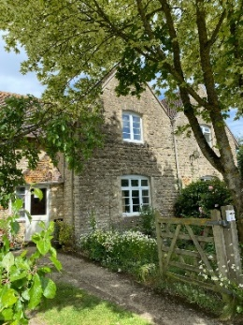
The eastern end of Station Road at the Football Field and the former Eynsham Park Estate cottages has important character as a ‘gateway’ from this direction. The T junction at, and the area to the West of, Margery Cross includes an important group of listed buildings, but also a long line of later 20th-century houses which, as suggested above, provide linkage between what might otherwise be dispersed areas of historic settlement.

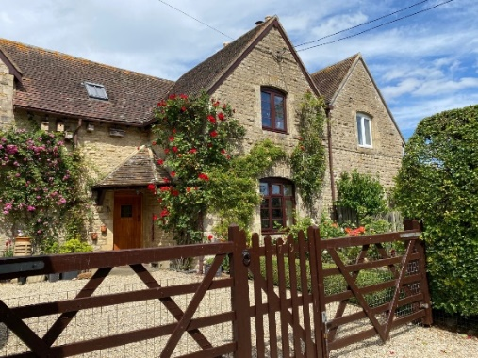
We submit that these and those in Station Road contribute to the “special architectural or historic interest” of the villages. Their linear quality and consistent distance from the road are helpful in this respect, and reinforce the village’s historic plan form. Those on Chapel Road also lie within the setting of the listed buildings. We submit that they are worthy of inclusion.
(Left): The later 19th-century building stock, largely a legacy from the Eynsham Park Estate.

The inter-connecting open farm land that forms an integral part of the area provides bucolic views and creates the ‘setting’ for entry into South Leigh from the West past the thatched Shuttles and two of the Parish’s oldest listed properties, the National Trust’s Wayside Cottages (Bottom right).
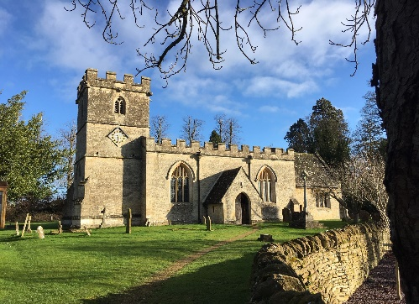
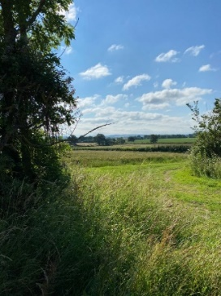
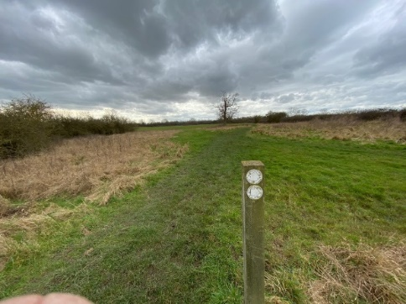

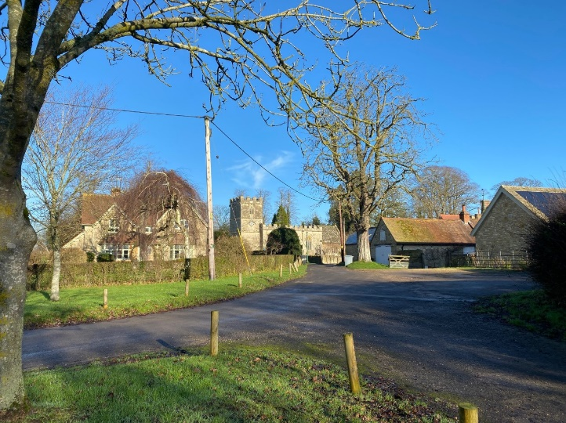
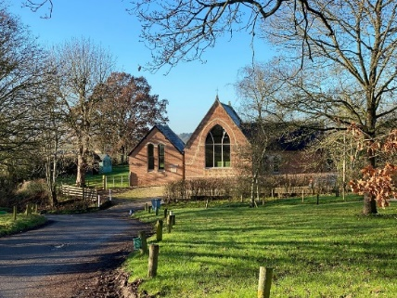
(Above/below): The 12th Century Church and its surroundings. (Below): The Village Hall and Village Green.

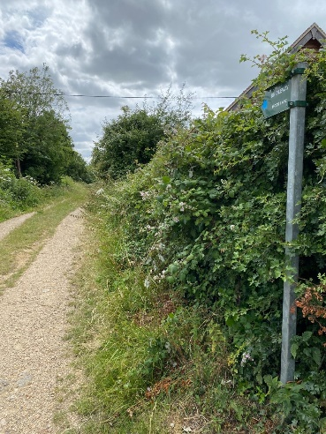
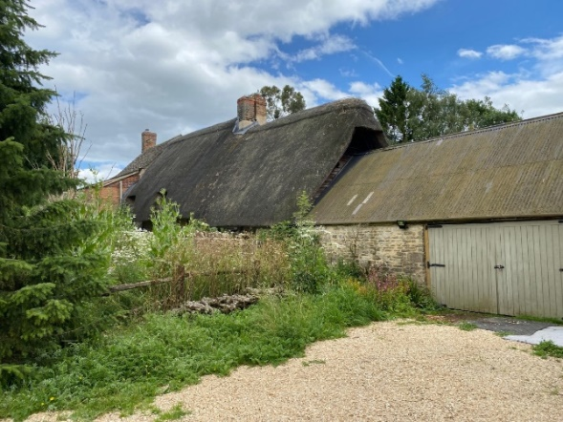
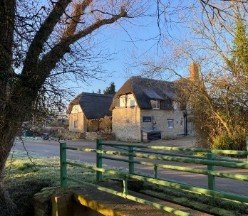
(Below): The ancient Moor Lane (Below): The listed 17th Century pub (Below): National Trust Wayside Cott’s

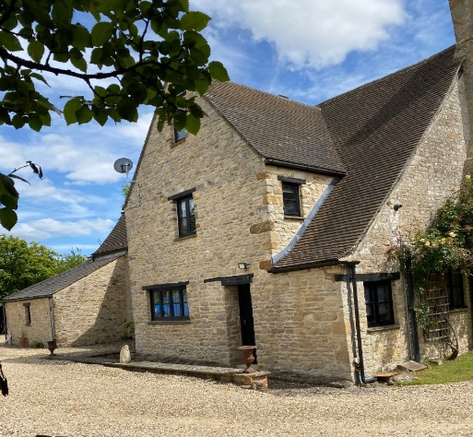
(Below): Listed Homan’s Farm (Below): Former Eynsham Park Estate cottages
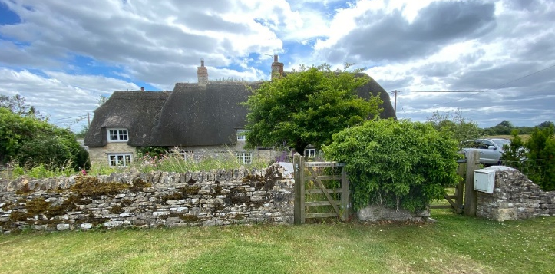
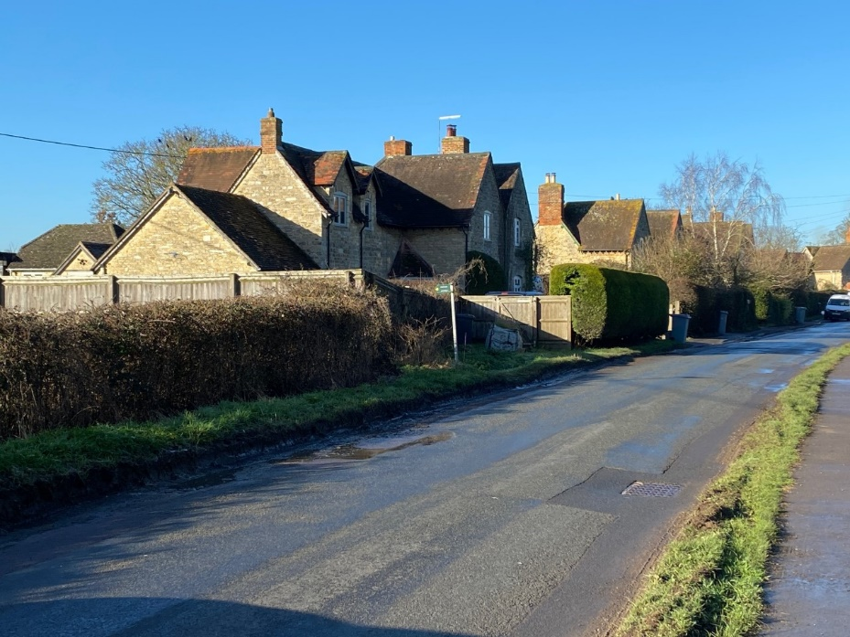
(Below): The listed, thatched Acre Cottage and the spur up Chapel Road and (Below): Kimber’s Break
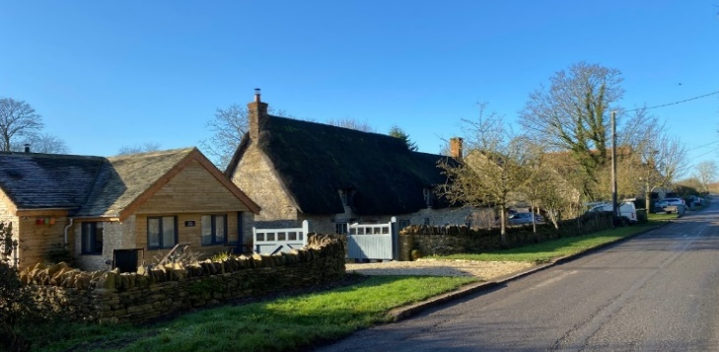
3.2. Core Area B - High Cogges
High Cogges hamlet is a legitimate, ‘self-defining Core Area’ that deserves Conservation Area status’.
Our Consultant comments, “High Cogges is, to my mind, a self-defining core zone – although an argument could be made here that the settings of the listed buildings provide sufficient protection for the area as a whole in terms of heritage designations. I do not think that argument holds up, however, and believe the hamlet deserves CA status in conjunction with South Leigh”.

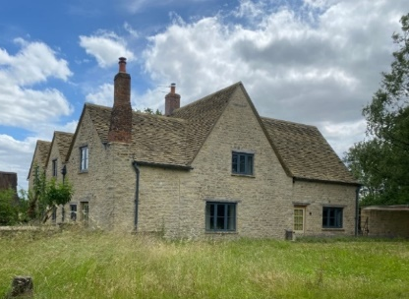
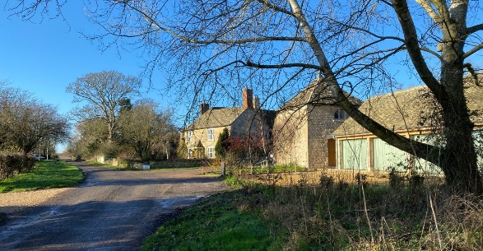
(Below): High Cogges Farm House and cottages.

7. Conclusion and Submission
As a Parish Council, we had aspirations of a much larger area embraced in a potential Conservation Area, as shown on Page 3. because that is the wish of residents. However, for the pragmatic reasons stated above and largely based on professional advice, not least from WODC’s own adviser, we respectfully submit this presentation for consideration of the smaller, defined Core Areas A and B, as described above.

It is our role to represent our electorate and to seek the maximum protection possible in order to maintain the beauty and heritage of our Parish, which is under threat. We do understand that, were the two smaller areas to be awarded Conservation Area status, that the adjoining and inter-connected areas for which we have reluctantly not applied, would also benefit from that protection, to some degree.

However, once your representatives have considered this application and visited the sites, were the Council prepared to consider including any or all of the additional spaces and their buildings covered in our ‘aspirational areas’ that link and/or form buffers between the two Core Areas, then we would be very pleased to re-submit.

Thank you for your attention and interest in the protection of the beauty and heritage of where we live and where others visit to enjoy the country side.

We shall be happy to provide any further information and/or to accompany any Councillor around either or both of the submitted areas and the land and properties between them.

Thank you,

Signatures
Conservation Area Steering Group of the South Leigh and High Cogges Parish Council.

Gary Nicholls: 7920771897. Dick Pears: 07850175729. Martin Spurrier: 07799368464.

[Date?]

