Media Release – For immediate release

Industrial scale, noxious gas production plant planned for sleepy West Oxon village near Witney to be larger than Wembley.

28th March 2023: The population of the tiny community of South Leigh & High Cogges is fuming about the prospect of an 'enormous' flammable, poisonous gas production plant planned to be just 250 metres from some private homes and on a green field site.

“There is nothing good about it for South Leigh & High Cogges”, said concerned resident, Matt Glithero.

“The plant would generate an enormous additional traffic load placing South Leigh & High Cogges country road users, horses and their riders, and walkers at risk, never mind those in Witney's Oxford Hill area where the traffic and air pollution are already at a breaking point", he said. Mr. Glithero stressed, “According to the developer’s own documentation, some 12,958 unprecedented HGVs/tractor trips would be expected each year, that's one every 19 minutes plus another one every 3.6 minutes during harvest”.

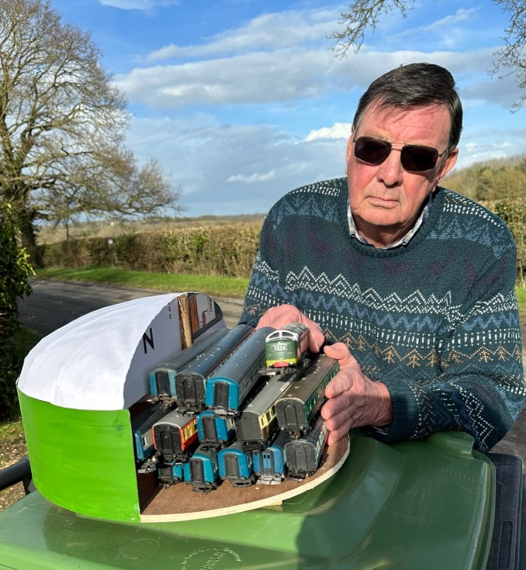
Another concerned resident, John Alexander, said, "The scale of the plant and the potential impact on the environment and our rural community would be enormous.

He points out that the proposed 6.99-hectare site is 1.5 times the area of the Wembley Stadium roof and each of the proposed five ‘fermenter tanks’ would be the height of four double decker busses standing on top of one another, and each would be able easily to swallow two full length, 13-carriage inter-city trains, plus their locomotives.

Picture shows: Concerned High Cogges resident, John Alexander, demonstrates the number of train carriages (26 plus the two locomotives) that would fit into just one of the five proposed fermenter tanks. The scales are accurate.

He said that two slurry 'lagoons' for pre-treatment of 'wastewaters' would total 1.25 acres and that some 93,000 tonnes of feedstock would be processed each year including tons of poultry litter, farmyard manures and spent crops. "This would be a nightmare for the 330 residents of South Leigh & High Cogges, plus those in east Witney”, Mr. Alexander said.

David Hindley, whose house is one of the closest, added, “It's a slap in the face to our Neighbourhood Plan and would run roughshod over the policies addressing environmental issues of noise, light, smell, traffic and industrial development on a green field site as well as the rural tranquility of the area”.

Mr. Glithero points to the Environment Agency's own report, 'A Review of Environmental Incidents at Anaerobic Digestion (AD) Plants and Associated Sites between 2010 and 2018’ *. "No matter how much 'greenwashing' the developer, Acorn Bioenergy, may put out, the reality is set out unequivocally in the Government's own Environment Agency's report. It makes horrific reading and underscores the real risk of pollution among other potential perils”, he said.

Mr. Hindley concluded, "The developer's 'greenwashing' and very questionable green criteria cannot gloss over its intention to build an industrial scale, flammable and poisonous gas production installation of 7 hectares on agricultural land a stone’s throw from residential homes". We have not seen any cogent reasons as to why the location has been chosen. "The noxious gas produced at the plant would need to be taken by tanker to Banbury for injection into the gas grid”, he said. "That's 25 miles away! This is the wrong location in every respect".

More information is on the West Oxfordshire District Council website. The planning consultation is open until 30th March and objections should be filed by then and thereafter. Visit: www.westoxon.gov.uk/planning Reference: 23/00179/FUL.

ends

Issued by concerned residents of South Leigh & High Cogges. For further information, please contact: David Hindley 01993 708007
Illustrations are also attached.
*Note to Editors:
See: https://consult.environment-agency.gov.uk/environmental-permitting/standard-rules-consultation-no-20/user_uploads/incidents-report--2010-2018--final.pdf
